MSSQL Sales Analysis
1) Data Cleaning: Replace values LF and low fat by Low Fat
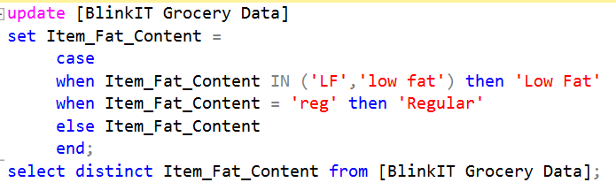
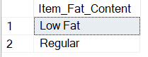
2) Total Sales (In Millions)
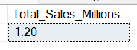
Total Sales
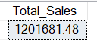
3) Average Sales
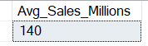
4) No of Items
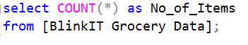
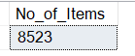
5) Average of Rating
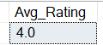
6) Total Sales by Fat Content
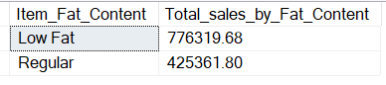
7) Total Sales by Item Type
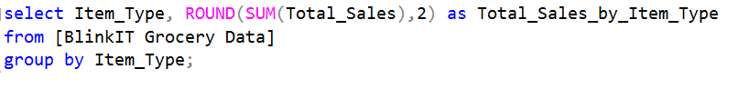
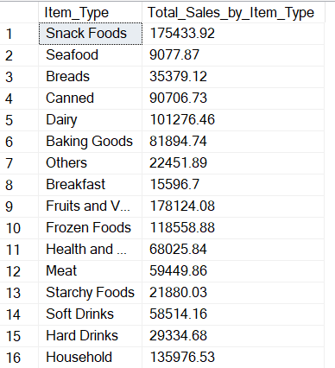
8) Total Sales by Location Type and Fat
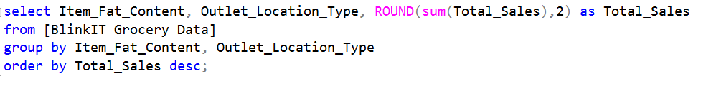
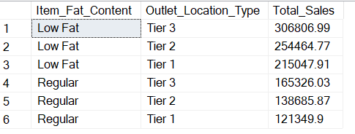
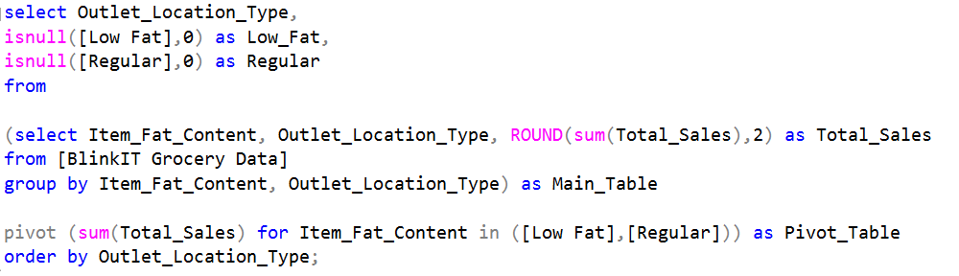
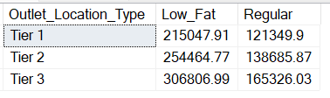
9) Total Sales by Establishment Year
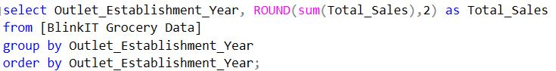
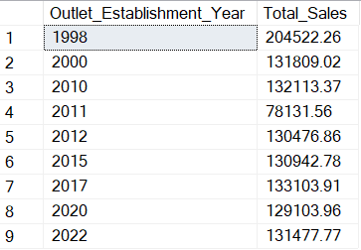
10) Total Sales by Outlet Size
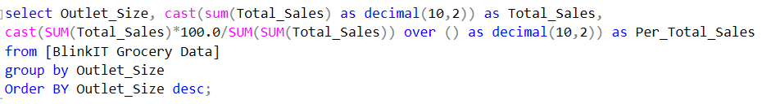
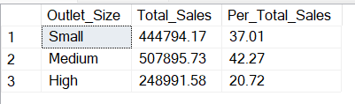
11) Total Sales by Outlet Location
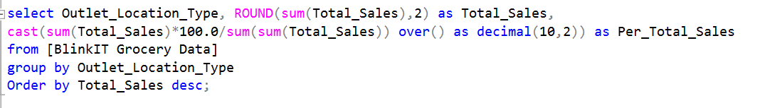
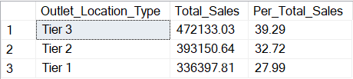
12) Total Sales, Average Sales, No of Items Average Rating and Item Visibility by Outlet Type
